MUTHAYAMMAL COLLEGE OF ARTS AND SCIENCE ,RASIPURAM



“Unearthing the Environmental Impact of Human Activity: A Global CO2 Emission Analysis”.

Our Team,

Team Leader: KARTHIK.M(20UEL1058)

Team members: KARTHIK RAJA.M(20UEL1059)

MOULEESWARAN.M(20UEL1061)

MALARAVAN.E(20UEL1060)

“Unearthing the Environmental Impact of Human Activity: A Global CO2 Emission Analysis.”

CO2 Emission Analysis.”

**Project Description**

.

Determine the exclusive global amount of carbon dioxide and other greenhouse gases accumulated over the full lifecycle of a product, service, or operation.

Combustion of fossil fuels (coal, natural gas, and oil) for energy and transportation.

Certain industrial processes and land-use changes also emit CO2. The main sources of CO2 emissions in the United States are described below. Transportation.

Carbon dioxide emissions per therm are determined by converting million British thermal units (mmbtu) to therms, then multiplying the carbon coefficient times the fraction oxidized times the ratio of the molecular weight of carbon dioxide to carbon (44/12).

**TechnicalArchitecture**

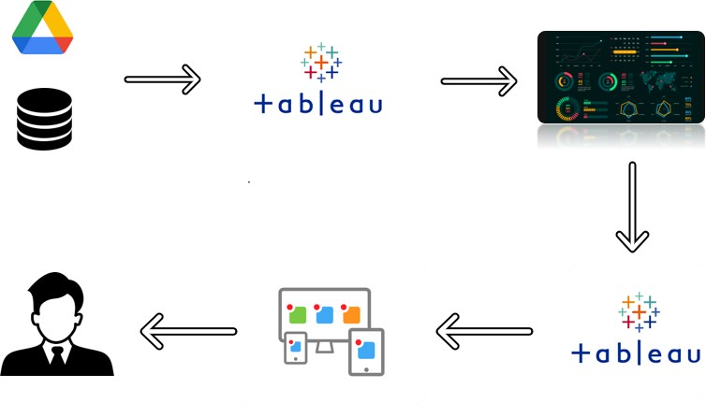

**Project Flow**

Toaccomplishthis,wehavetocompletealltheactivitieslistedbelow,

* DefineProblem/ProblemUnderstandingo Specifythebusinessproblem
  + Businessrequirements
  + LiteratureSurvey
  + SocialorBusinessImpact.
* DataCollection&ExtractionfromDatabase
  + Collectthedataset,
  + StoringDatainDB
  + PerformSQLOperations
  + ConnectDBwithTableau
* DataPreparation
  + PreparetheDataforVisualization
* DataVisualizations
  + NoofUniqueVisualizations
* Dashboard
  + ResponsiveandDesignofDashboard
* Story
  + NoofScenesofStory
* PerformanceTesting
  + AmountofDataRenderedtoDB‘
  + UtilizationofDataFilters
  + NoofCalculationFields
  + NoofVisualizations/Graphs
* WebIntegration
  + DashboardandStoryembedwithUIWithFlask
* ProjectDemonstration&Documentation
  + RecordexplanationVideoforprojectendtoendsolution
  + ProjectDocumentation-Stepbystepprojectdevelopmentprocedure

# Milestone1:DefineProblem/ProblemUnderstanding

## Activity 1: Specify the business problem

Refer Project Description

## Activity 2: Business requirements

A Carbon audit, sometimes referred to as a 'carbon footprint', is a means of measuring and

recording the greenhouse gas (GHG) emissions of an organization or building within a

defined system boundary.

The formula to calculate the carbon footprint of a business is simple: the result is obtained by

multiplying the activity (or consumption) data by its corresponding emission factor. Based on

this formula, there are several methodologies to calculate the carbon footprint

(UNE-ISO 14064, GHG Protocol, etc).

Statutory Audit as the name suggests is a compulsory audit for all companies. Every entity

which is registered under the Companies Act, as a Private Limited or a Public Limited

company has to get its books of accounts audited every year.

## Activity3:LiteratureSurvey(StudentWillWrite)

The carbon (and oxygen) in CO2 can be used as an alternative to fossil fuels

in th production of chemicals, including plastics, fibres and synthetic rubber. As with

CO2- derived fuels,converting CO2 to methanol and methane is the most technologically

mature pathway.

Carbon dioxide in the atmosphere warms the planet, causing climate change.

Human activities have raised the atmosphere's carbon dioxide content by 50% in less

than 200 years.

What is carbon dioxide? Carbon dioxide is the fourth most abundant gas in the

earth's atmosphere.At room temperature, carbon dioxide (CO2) is a colorless, odorless,

non-flammable gas, at other temperatures and pressures, carbon dioxide can be a liquid

or a solid.

## Activity 4: Social or Business Impact..

## An extra ton of carbon emissions shortens lifespans, hurts crops, and causes sea levels to rise, decreasing property values. An SCC of $51 means that economists and climate scientists expect the total damages from an extra ton of carbon emissions to equal $51 a ton.

## Higher carbon footprint is indicative of greater energy costs. Expenditure on energy bills could be channeled to other areas of the business that require more attention.

## Scientific studies show that climate change will have, and in some cases has already had, severe consequences for society, like the spread of disease, increased food insecurity, and coastal destruction..

# Milestone2:DataCollection&ExtractionfromDatabase

Data collection is the process of gathering and measuring information on variables of interest, in anestablishedsystematicfashionthatenablesonetoanswerstatedresearchquestions,testhypotheses,andevaluateoutcomesandgenerateinsightsfromthedata.

## Activity 1: Collect the dataset

Pleaseuse the link to download the dataset: https://drive.google.com/file/d/1n764uDPT_ZF7kzGFLtpxkwBBsDBScbWm/view?usp=sharing

### Activity1.1:Understand the data:

### Greenhouse gas concentrations are measured in parts per million, parts per billion, and even parts per trillion. One part per million is equivalent to one drop of water diluted into about 13 gallons of liquid (roughly the fuel tank of a compact car).

### Carbon dioxide (CO2): Fossil fuel use is the primary source of CO2. CO2 can also be emitted from direct human-induced impacts on forestry and other land use, such as through deforestation, land clearing for agriculture, and degradation of soils.

### CO2 is measured as parts per million (ppm), which is numerically equivalent to micromoles of CO2 per mole of air. The SI unit for CO2 concentration is µmol per mol.

### Column Description for CO2Emission Analysis Data Clean:

Carbon dioxide emissions are those stemming from the burning of fossil fuels and the manufacture

of cement. They include carbon dioxide produced during consumption of solid, liquid, and gas fuels

and gas flaring. Source. Climate Watch. 2020.

Natural sources of carbon dioxide include most animals, which exhale carbon dioxide as a waste

product. Human activities that lead to carbon dioxide emissions come primarily from energy

production, including burning coal, oil, or natural gas.

Because air pollution and greenhouse gases are often released from the same sources, cutting

greenhouse gas emissions in an effort to slow climate change also reduces air pollutants, such as

fine particulate matter (PM2.5). Reducing these co-emitted air pollutants improves air quality and

benefits human health.

### ColumnDescriptionforCheapestelectriccars-EVDatabase:

1. Name
2. Subtitle
3. Acceleration
4. TopSpeed
5. Range
6. Efficiency
7. FastChargeSpeed
8. Drive
9. NumberofSeats
10. PriceinGermany
11. PriceinUK

## Activity 2: Storing Data in DB & Perform SQLOperations

## Storing Data in DB & Connect DB with Tableau

Explanation video link:

https://drive.google.com/file/d/1WUK_E6SJbev4eByoyGUlubsJ2yiifvgz/view?usp=sharing

# Milestone3:DataPreparation

## Activity1:Preparethe DataforVisualization

Preparing the data for visualization involves cleaning the data to remove irrelevant or missingdata, transforming the data into a format that can be easily visualized, exploring the data toidentify patterns and trends, filtering the data to focus on specific subsets of data, preparingthe data for visualization software, and ensuring the data is accurate and complete. Thisprocesshelpstomakethedataeasilyunderstandableandreadyforcreatingvisualizationstogaininsightsintotheperformanceandefficiency.

# Milestone4:DataVisualization

Datavisualizationistheprocessofcreatinggraphicalrepresentationsofdatainordertohelppeopleunderstand and explore the information. The goal of data visualization is to make complex data setsmore accessible, intuitive, and easier to interpret. By using visual elements such as charts, graphs,and maps, data visualizations can help people quickly identify patterns, trends, and outliers in thedata.

## Activity1:NoofUniqueVisualizations

### Activity1.1: Understand- Total World Emission,

### Co2 Emission over Time, Total Emission by

### Continent

### 2eeefff4-3dcd-4465-8bf1-f635f22a15c7.jfif

### Sheet 2394b9c3e-0639-4196-a7f9-6435be3626a6.jfif

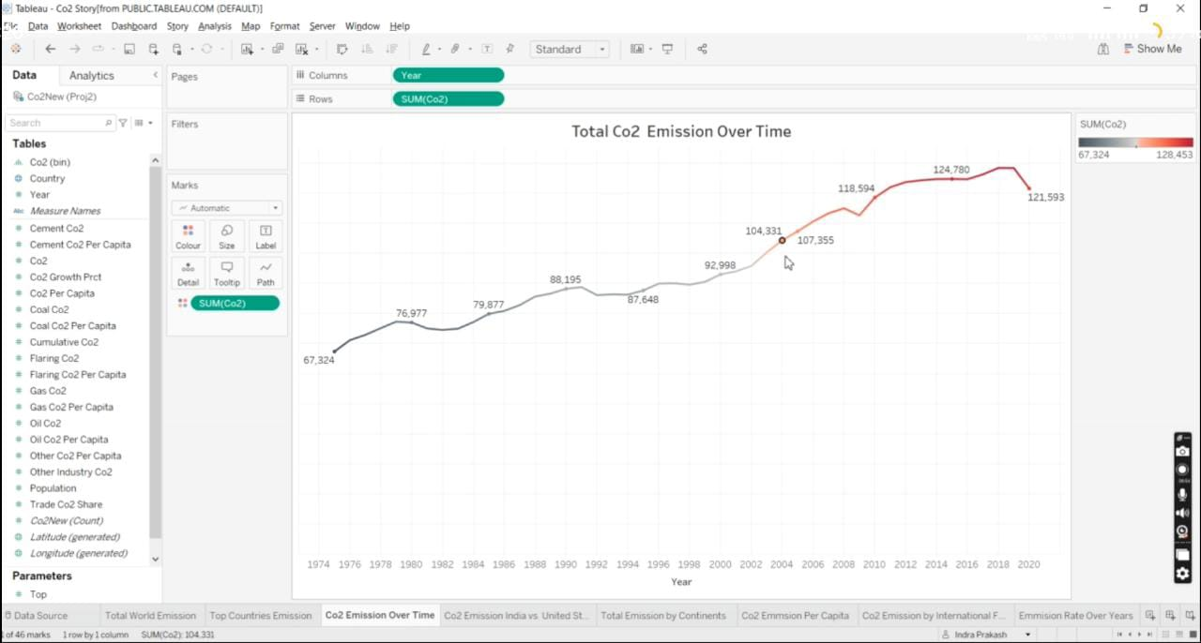

### 1234567890.jfif

### Activity1.2: To Understand- Co2 Emission per Capita, Co2 Emission by

### International Factors, Emission Rate Over Year.

### 2.jfif

### 3.jfif

### 4.jfif

### 5.jfif

**Activity 1.3: To Understand- Co2 contribution by different fossil fuels, Co2**

**Emission over past 10 Years, Change in Co2 Emission and Co2 Emission in**

**2020**

### 11.jfif

### 12.jfif

### 13.jfif

### 14.jfif

### Milestone 5: Dashboard

### A dashboard is a graphical user interface (GUI)that displays information and data in an organgized, easy-to-read format. Dashboards are often user to provide real-time monitioring and analysis of data, and are typically design for a specific purpose or use case.

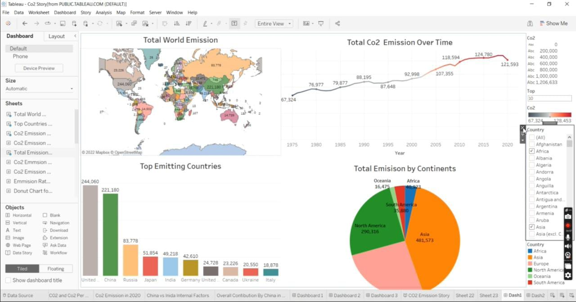

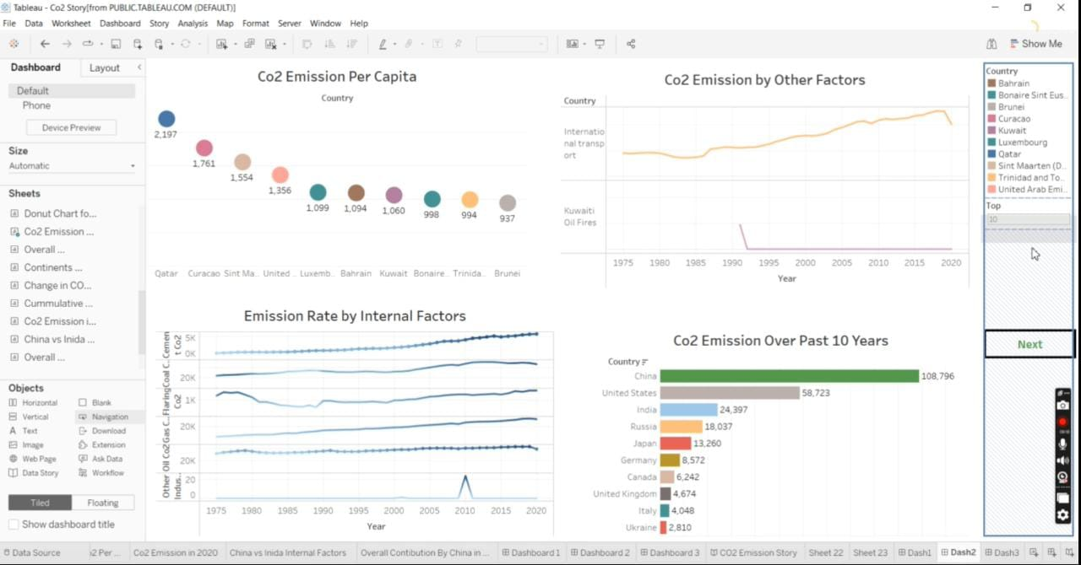

### 03.jfif

# Milestone5:Dashboard

A dashboard is a graphical user interface (GUI) that displays information and data in an organized,easy-to-read format. Dashboards are often used to provide real-time monitoring and analysis of data,andaretypicallydesignedforaspecificpurposeorusecase.Dashboardscanbeusedinavarietyofsettings, such as business, finance, manufacturing, healthcare, and many other industries. They canbe used to track key performance indicators (KPIs), monitor performance metrics, and display data intheformofcharts,graphs,andtables.

## Activity :1- Responsive and Design of Dashboard

### Explanationvideolink: https://drive.google.com/file/d/1dMO07jzPoE-xLluqPVe9lYK6LiqDwfAD/view?usp=drivesdk

# Milestone6:Story

A data story is a way of presenting data and analysis in a narrative format, with the goal of making theinformation more engaging and easier to understand. A data story typically includes a clearintroduction that sets the stage and explains the context for the data, a body that presents the dataand analysis in a logical and systematic way, and a conclusion that summarizes the key findings andhighlights their implications. Data stories can be told using a variety of mediums, such as reports,presentations,interactivevisualizations,andvideos.

**Activity:1- No of Scenes of Story**

### Explanationvideolink: https://drive.google.com/file/d/1psOWLGfa38X65KIA7EtQk0KLycf3SUs8/view?usp=sharing

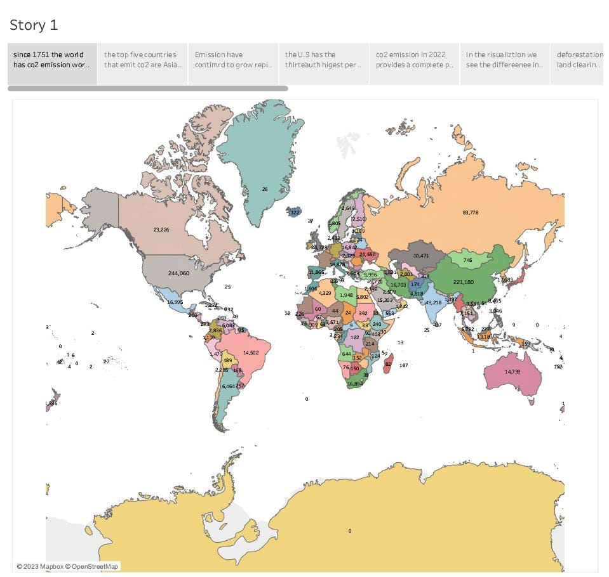

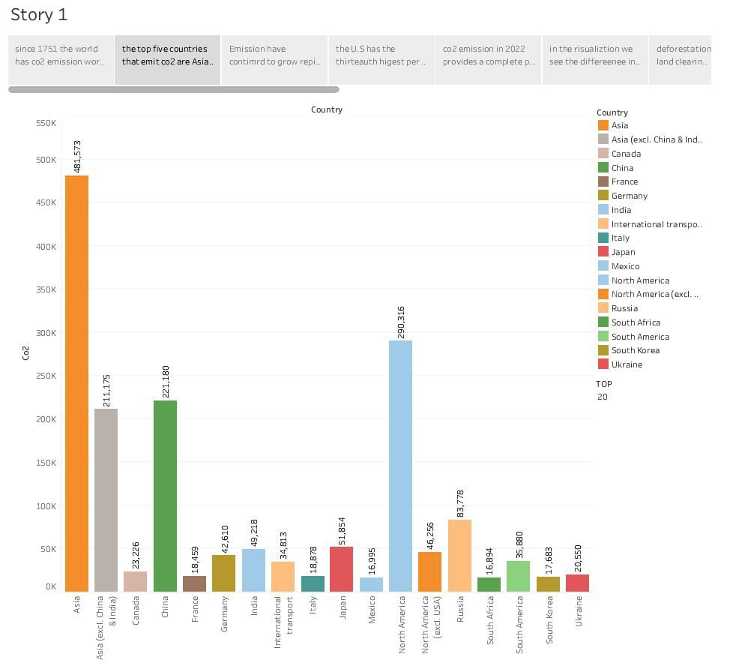

# Milestone7:PerformanceTesting

## Activity 1:Amount of Data Rendered to DB

* + - The amount of data that is rendered to a database depends on the size of thedatasetandthecapacityofthedatabasetostoreandretrievedata.
    - Open the SQL Server Management Studio, go to the database then click to

expand the tables, select the table and Right click and select Properties.

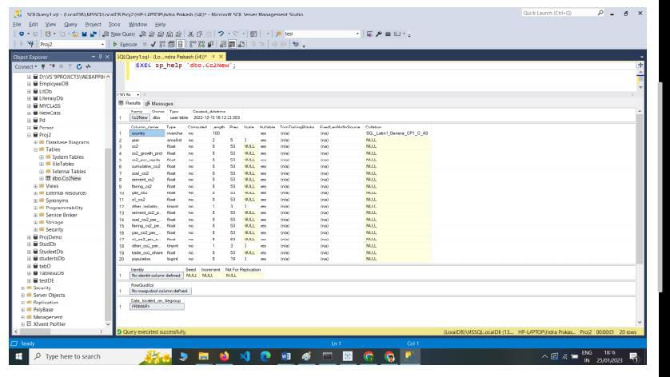

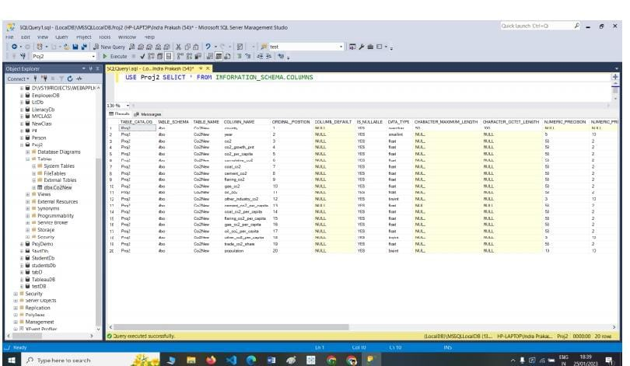

## Activity 2: Utilization of Data Filters

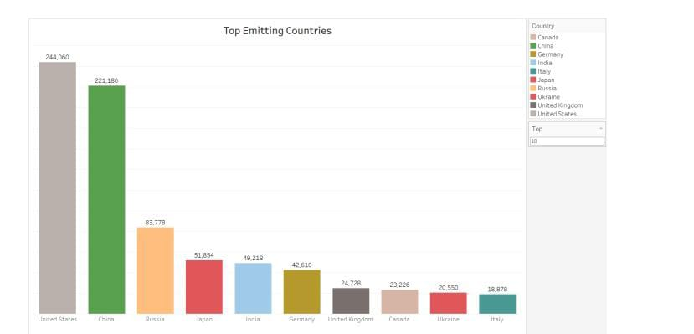

**Activity 3: No of Calculation Fields**

1. Top World Emission

2. Top Emitting Countries

3. Co2 Emission over Time

4. Co2 Emission India vs USA

5. Total Emission by Continents

6. Co2 Emission per Capita

7. Co2 Emission by International Factors

8. Emission Rate over Years

9. Donut Charts-Coal Co2,Cement Co2,Gas Co2,Oil Co2

10. Co2 Emission over past 10 years

11. Continent Contribution in Co2 Emission

12. Cumulative Co2 and Co2 per Capita

13. Co2 Emission in 2020

14. China vs India Co2 emission due to internal factors

15. Overall Contribution by China

# Milestone8:Webintegration

Publishing helps us to track and monitor key performance metrics, to communicate results andprogress.helpapublisherstayinformed,makebetterdecisions,andcommunicatetheirperformancetoothers.

### Publishingdashboardandreportstotableaupublic

Step1:GotoDashboard/story,clickonsharebuttononthetopribbon

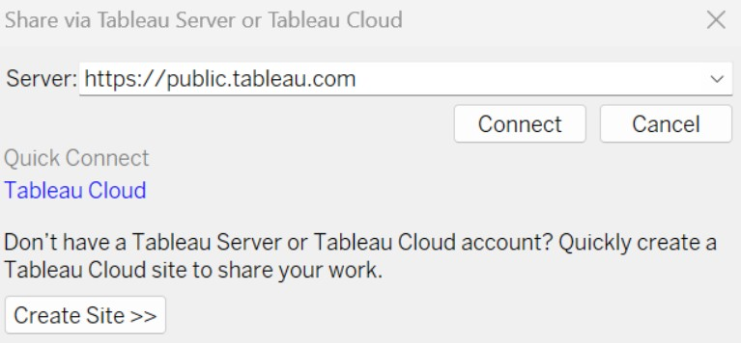

Givetheserveraddressofyourtableaupublicaccountandclickonconnect.

### ExplanationVideo:-

https://drive.google.com/file/d/1T6GA7LvIh0QXIPuUcR1TJtd66YQI7pma/view?usp=sharing

**Step2:**Onceyouclickonconnectitwillaskyoufortableaupublicusernameandpassword

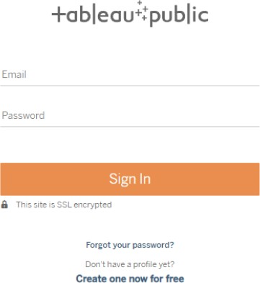

Onceyouloginintoyourtableaupublicusingthecredentials,theparticularvisualizationwillbepublishedintotableaupublic

**Note:Whilepublishingthevisualizationtothepublic,therespectivesheetwillgetpublishedwhenyouclickonshareoption.**

**Activity1: Dashboard andStory embed withUI With Flask**

### Explanationvideolink:

https://drive.google.com/file/d/12JmI6meo3yw_YZOP1yGpvTQshcHceEU8/view?usp=sharing

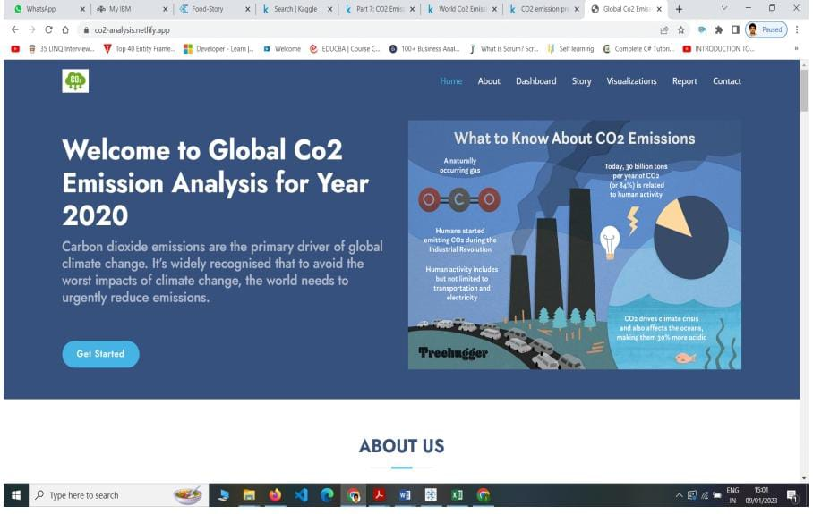

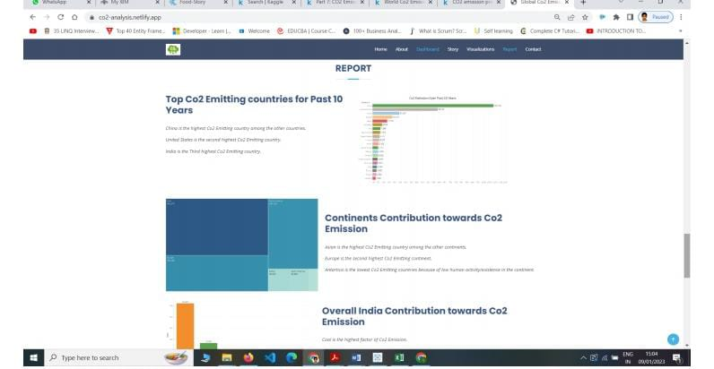

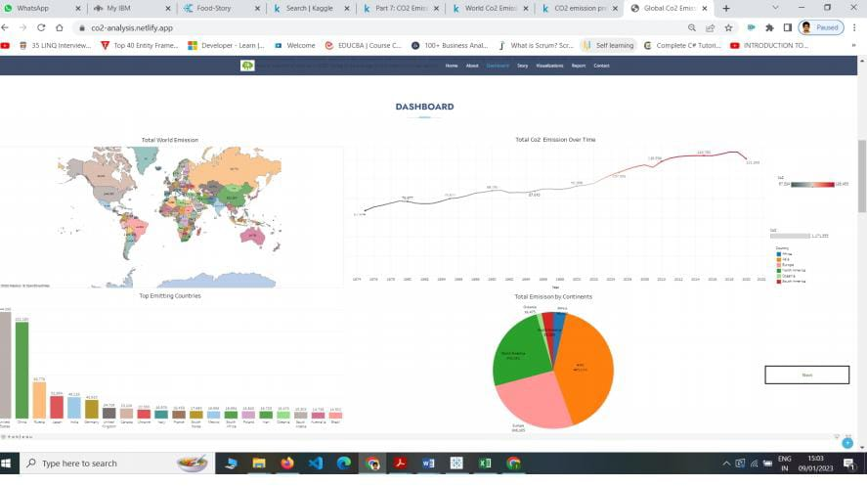

# Milestone9:ProjectDemonstration&Documentation

## Activity1:- Recordexplanation Videofor projectend toend solution

## Here is the link for our record explanation video for our project:

## 

**https://drive.google.com/file/d/1dMO07jzPoE-xLluqPVe9lYK6LiqDwfAD/view?usp=drivesdk**

**Activity 2:- Project Documentation-Step by step project developmentprocedure**

**Activity 3:- HTML WEBSITE file:///E:/html/Arsha/Arsha/index.html**